

**AMERICAN INTERNATIONAL UNIVERSITY–BANGLADESH (AIUB)**

**FACULTY OF SCIENCE & TECHNOLOGY**

**DEPARTMENT OF PHYSICS**

**PHYSICS LAB 1**

**Summer 2020-2021**

**Section: D , Group: 1**

**LAB REPORT ON**

***(a) Study of Ohm’s law using unknown resistances.***

***(b) Determination of the equivalent resistances for series and parallel combinations of resistors.***

**Supervised By**

**Bithi Paul**

**TABLE OF CONTENTS**

|  |  |
| --- | --- |
| **TOPICS** | ***Page no*.** |
| 1. **Title Page** | 1 |
| 1. **Table of Content** | 2 |
| 1. **Theory** | 3 |
| 1. **Apparatus** | 4 |
| 1. **Procedure** | 4 |
| 1. **Experimental Data** | 5 |
| 1. **Analysis and Calculation** | 6-7 |
| 1. **Result** | 8 |
| 1. **Discussion** | 8 |
| 1. **References** | 9 |
|  |  |

1. **Theory**

Ohm's law states that the current through a conductor between two points is directly proportional

to the voltage across those two points. Introducing the constant of proportionality, the resistance, one arrives at the usual mathematical equation that describes this relationship:

𝑉 = 𝐼𝑅

where *I* is the current and V is the potential difference across the resistance R.

Rh

Rx V

V

Slope = R

A

(a) (b) I



Figure 4.1: (a) Simple circuit to determine unknown resistance, Rx by using Ohm’s law, ammeter (A) and voltmeter (V) are used to measure the current and potential drop in the circuit, variable resistor, Rh is used to change the current flow in the circuit (b) Slope of the V vs I graph gives

the value of R.

When *N* number of resistors are connected in series and parallel connections their equivalent resistances *Rs* and *Rp* are calculated by the following two equations:

R𝑠 = R1 + R2 + ⋯ + Rn

1

=

R𝑝

Rh



1

+

R1

1

R2

+ ⋯ +

1

R𝑁

Rh



R1 R1

V

R2

A A

R2 V

(a) (b)

Figure 4.2: Series and parallel connections are shown for two resistors R1 and R2 in (a) and (b), respectively.

1. **Apparatus**

* Power supply,
* Variable resistance,
* Ammeter,
* Voltmeter,
* Unknown resistance,
* Connecting wires.

1. **Procedure**

* Construct above circuits with 2 unknown resistances (R1 & R2).
* Using rheostat Rh choose current not more than 1 A. Vary Rh to select 10 different

Currents through the circuit as measured by the ammeter A.

* Measure the corresponding potential differences (V) in the voltmeter.

1. **Experimental Data**

Table 1: Voltage current records for R1 and R2

|  |  |  |
| --- | --- | --- |
| **Resistors** | **Current**  **I (A)** | **Voltage**  **V (V)** |
| **R1** |
| 0.05 | 0.05 |
| 0.1 | 0.104 |
| 0.15 | 0.155 |
| 0.2 | 0.2012 |
| **R2** | 0.05 | 0.1163 |
| 0.1 | 0.201 |
| 0.15 | 0.2992 |
| 0.2 | 0.410 |

Table 2: Voltage current records for series and parallel connections

|  |  |  |
| --- | --- | --- |
| **Combinations of R1 & R2** | **Current**  **I (A)** | **Voltage**  **V (V)** |
| **Series Combination** | 0.05 | 0.171 |
| 0.1 | 0.319 |
| 0.15 | 0.451 |
| 0.2 | 0.617 |
| **Parallel Combination** | 0.05 | 0.0357 |
| 0.1 | 0.0699 |
| 0.15 | 0.1062 |
| 0.2 | 0.1341 |

1. **Analysis and Calculation**

**• Resistances from the graphs R1**

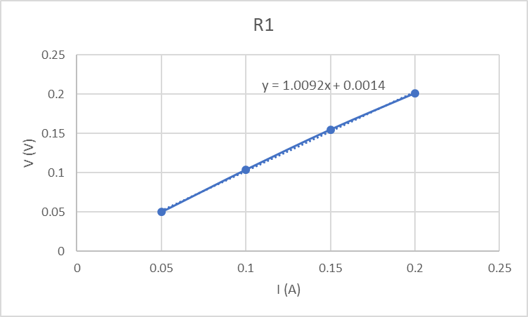

**• Resistances from the graphs R2**

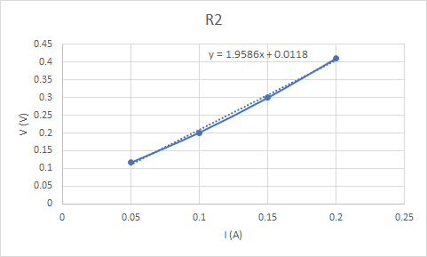

**• Resistances from the graphs Series Combination**

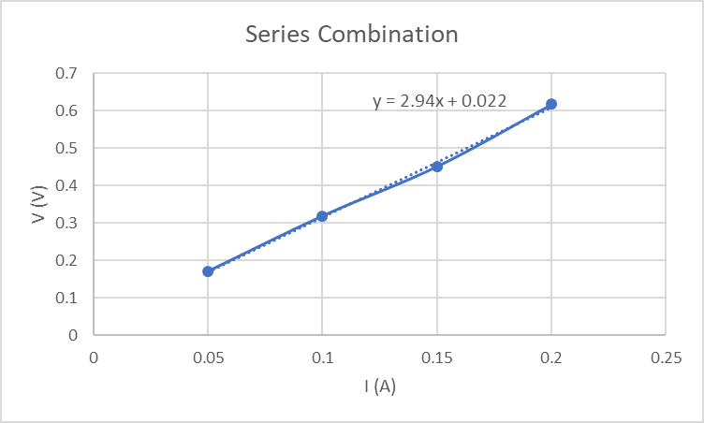

Calculated Values of Resistances in Series Combination

Rs = R1+R2

Rs = 1.0092+1.9586

Rs = 2.96 Ω

**• Resistances from the graphs Parallel Combination**

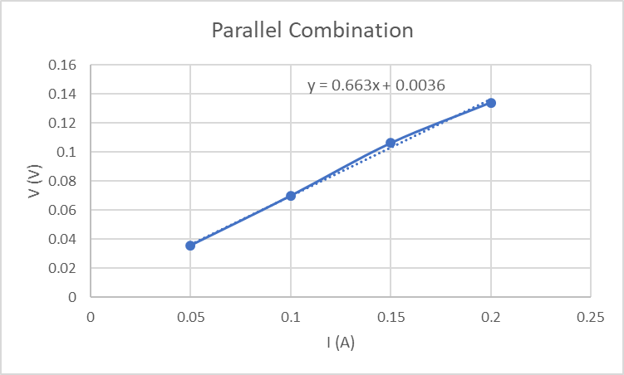

Calculated Values of Resistances in Parallel Combination

1/Rp = 1/R+1/R2

1/Rp = 1/1.0092+1/1.9586

Rp = 1.5014 Ω

1. **Result**

Table : Values of R1, R2, Rs and R

|  |  |  |  |
| --- | --- | --- | --- |
| Resistances from the graphs | | Calculated Values of Rs and Rp in Ohms | Comments |
| Resistors | Values in Ohms | Resistances of the resistor from the excel graphs are R1 =1.0092 Ω and R2 = 1.9586 Ω. Resistance of the resistors from the excel graph when they are connected in series is *RS* = 2.94 Ω and when they are connected in parallel is *RP* = 0.663 Ω.  Hand calculated value of the resistors are *RS* = 2.9678 Ω and *RP* = 0.666 Ω. |
| **R1** | 1.0092 |
| **R2** | 1.9586 |
| **Rs** | 2.94 | 2.9678 |
| **Rp** | 0.663 | 0.666 |

1. **Discussion**

* If there is a constant resistance in the circuit, the current is directly proportional to the voltage and will increase as the voltage increases.
* For a circuit with a constant resistance, current will have a directly proportional and hence linear relationship with voltage. This can be proven by looking at Ohm’s law V=I×R and also by looking at the graphs of this experiment

1. **References**

Fundamental of Physics (10th Edition): Ohm’s Law (Chapter 26, page 756-759)

* Video Links:
* <https://www.youtube.com/watch?v=Vh3XGz7hgU4>
* <https://www.youtube.com/watch?v=hxYn74Yhkpk>
* https://www.youtube.com/watch?v=2c1z4pLsI_w